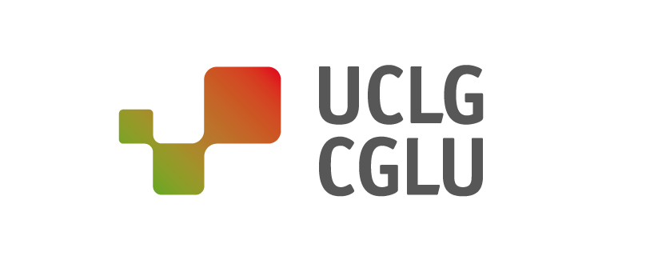
PRESS RELEASE

LOCAL ACTION AND LEADERSHIP: THE CORE OF THE TRANSFORMATION TOWARDS MORE SUSTAINABLE, SUPPORTIVE AND CREATIVE SOCIETIES

At the 2019 UN High-Level Political Forum (HLPF), local and regional governments will call for accelerated action to localize the Sustainable Development Goals (SDGs)
New York, 15 July 2018

It is essential to define the rights of a global citizenship through local realities. That is why, when we talk about getting a seat at global decision-making tables, we are seeking a seat for our communities and for those closest to the people being affected by these decisions. It is in cities where local leaders have the capacity to improve the well-being of citizens by listening directly to their desires and needs, and being the guardians of their aspirations.

The Global Taskforce, which brings together the constituency of local governments and their associations, hosts a Local and Regional Governments Day with the presence of Maimunah Mohd Sharif, Executive Director of UN-Habitat, and the President of the General Assembly María Fernanda Espinosa. On this day, the United Nations and member states who are committed to achieving the SDGs, will be called upon to involve local governments at all stages of the decision-making process. For only through co-creation between spheres of government will we be able to drive change in the global governance system.

The delegation of more than 130 local and regional government representatives has organized their presence at the HLPF around Local2030, a multi-stakeholder initiative that brings together local governments, national governments, civil society, and the private sector to discuss experiences and strengthen local knowledge, connecting all stakeholders to collaborate and accelerate action to achieve the SDGs.

Cities are listening

It is the cities and regions that work day by day to deal with the climate emergency, to reduce inequalities, to ensure decent growth for their citizens and a quality education that ensures no one and no place is left behind.

Taking into account the Seville Commitment, local and regional governments issue a call to cement a local-global movement to accelerate the localization of development agendas, and to place local governments and citizens at the core of political action, because only by promoting this territorial cohesion and co-creating strategies and alliances between all spheres of government will we be able to achieve the change we want for the world and for future generations.

In September of this year, the SDG Summit, convened by the UN General Assembly, will take place to review progress on the 2030 Agenda. During which, the collective of local governments will host the 2nd Local and Regional Governments Forum, with the aim of establishing high-level dialogues between different spheres of government and accelerate the achievement of the 2030 Agenda.

Cities show their commitment to sustainable development at the global level

To achieve this, it is necessary to localize the global development agendas, which need to be owned by our communities, and it is crucial for this process to be fully supported by all spheres of government.

Within the framework of this High Level Political Forum, the third Local and Regional governments’ report to the HLPF is presented. It shows how their mobilization for the localization of SDGs has spread across all continents. At the same time, it shows how national governments still have work to do in order to integrate local perspectives, since only 49 countries out of 143 consulted local and regional governments in the national coordination mechanisms for the implementation of the 2030 Agenda.

The solutions and reactions to major challenges are not the same from a distant perspective as they are when they come from the proximity of our communities. This is why we look forward to November and the UCLG World Congress, to see the future with eyes filled with hope, and to empower our constituency to collaborate and synergize in order to achieve make these hopes a reality.

------
About UCLG:

United Cities and Local Governments (UCLG) is the global organization that represents local and regional governments and their associations and works to defend their interests on the international scene. Representing 70% of the world's population, UCLG members are present in all regions of the world: Africa, Asia-Pacific, Europe, Eurasia, Middle East and West Asia, Latin America and Latin America, organised into seven continental sections, a metropolitan section and a Forum of Regions. UCLG has more than 240,000 cities, regions and metropolitan areas, as well as more than 175 local and regional government associations in 140 countries. Among its main areas of political interest, UCLG works on local democracy, climate change and environmental protection, achieving sustainable development objectives, local finance, urban development and city diplomacy for peace building.
---

CONTACT :
United Cities and Local Governments / Address C/Avinyo, 15 08003 Barcelona
Tlf +34 93 342 87 / Email communication@uclg.org / Redes sociales @uclg_org #Listen2Cities #HLPF2019 / Web https://www.uclg.org/

